Technological University of the Philippines

Ayala Blvd. Ermita, Manila 1000

[www.tup.edu.ph](http://www.tup.edu.ph)

COLLEGE OF SCIENCES

Bachelor of Science in Information System (NON-STEM)

1AB

COMPUTER PROGRAMMING

PROFESSOR: MAY GARCIA

GRADING SYSTEM

SYSTEM MANUAL

Members:

BERIN, SAMANTHA MAURICE

MALICDEM, ANTONIEL

SANCHEZ, LORDIRENE LLYLE PRINCE

TORRES, JHON PATRICK

Table of Contents

|  |  |
| --- | --- |
| Content | Pages |
| Title Screen | 3 |
| Main Menu | 3 |
| 1. Add New Student | 4 |
| 1. Edit Student | 5 |
| 1. Delete Student | 7 |
| 1. Display Student | 8 |
| 1. Display All | 9 |
| 1. Compute Grade | 10 |
| 1. Generate Grade Summary | 11 |
| 1. Exit | 12 |
| R. Reset All | 12 |

TITLE SCREEN

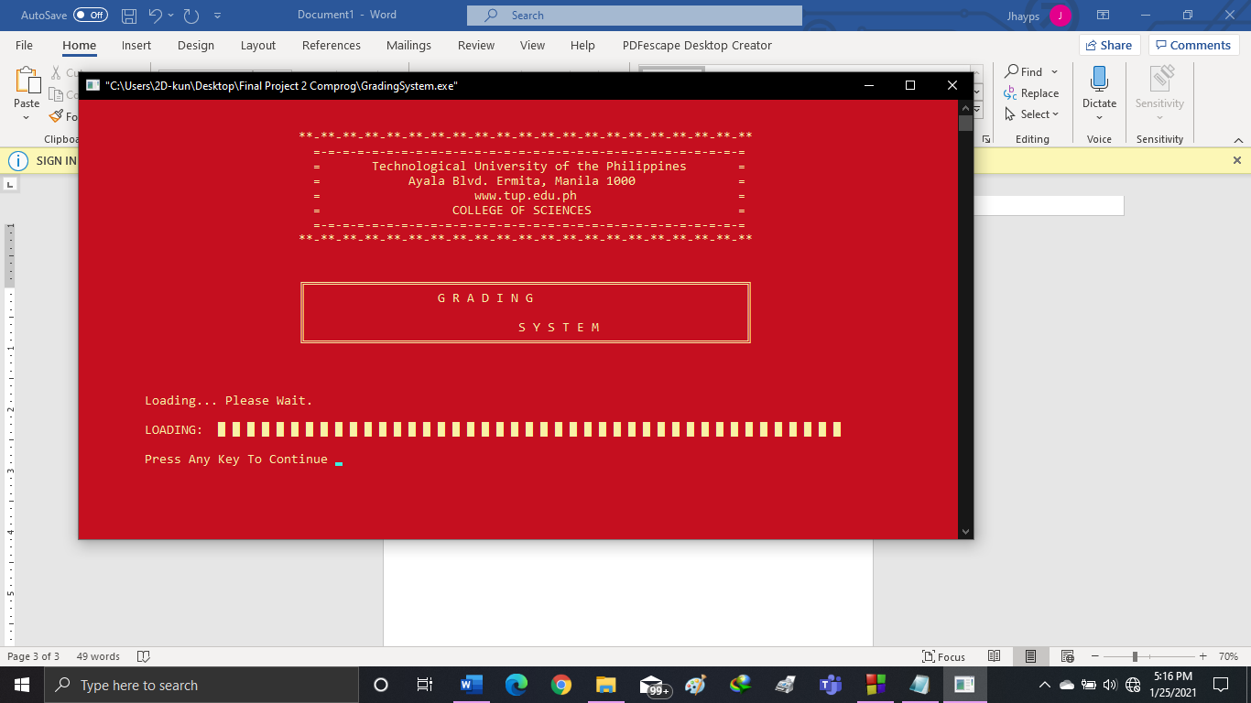

This part of the screen shows the entrance when the program starts. It shows here the name of the school, address, and the title page.

Press any key to continue to the Main Menu.

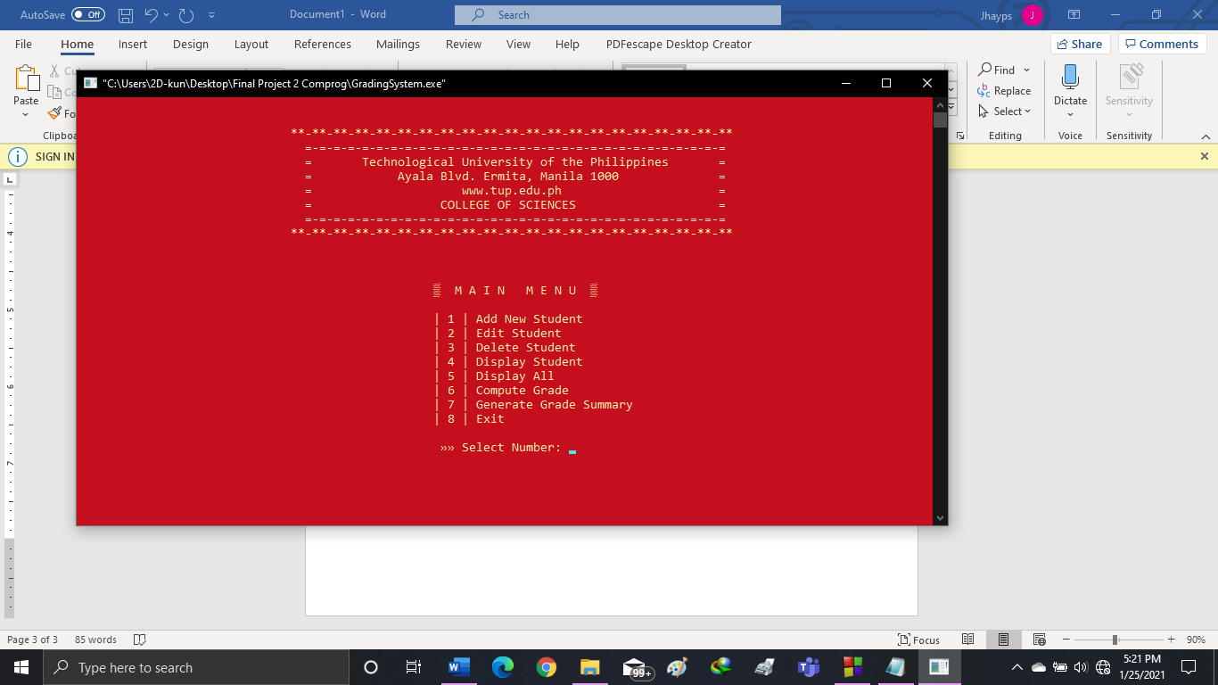MAIN MENU:

This screen shows the selection of the main menu. The main menu selection has:

1. Add New Student
2. Edit Student
3. Delete Student
4. Display Student
5. Display All
6. Compute Grade
7. Generate Grade Summary
8. Exit

Press any number you want to select and will automatically continue to the specific program.

1. 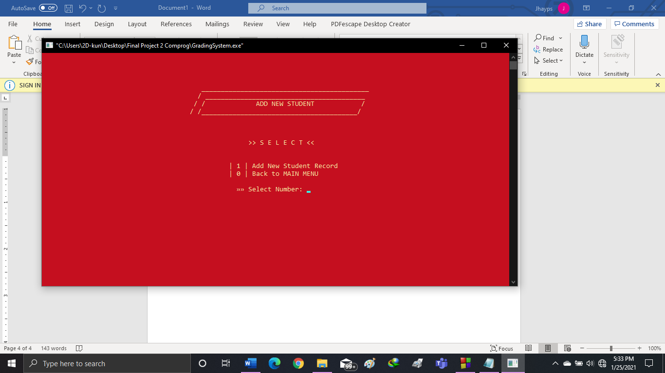ADD NEW STUDENT

If you Select the “Add New Student” in the MAIN MENU, it will show to this screen.

Press [1] to Select “Add New Student Record” or Press [0] if you want to go back to MAIN MENU

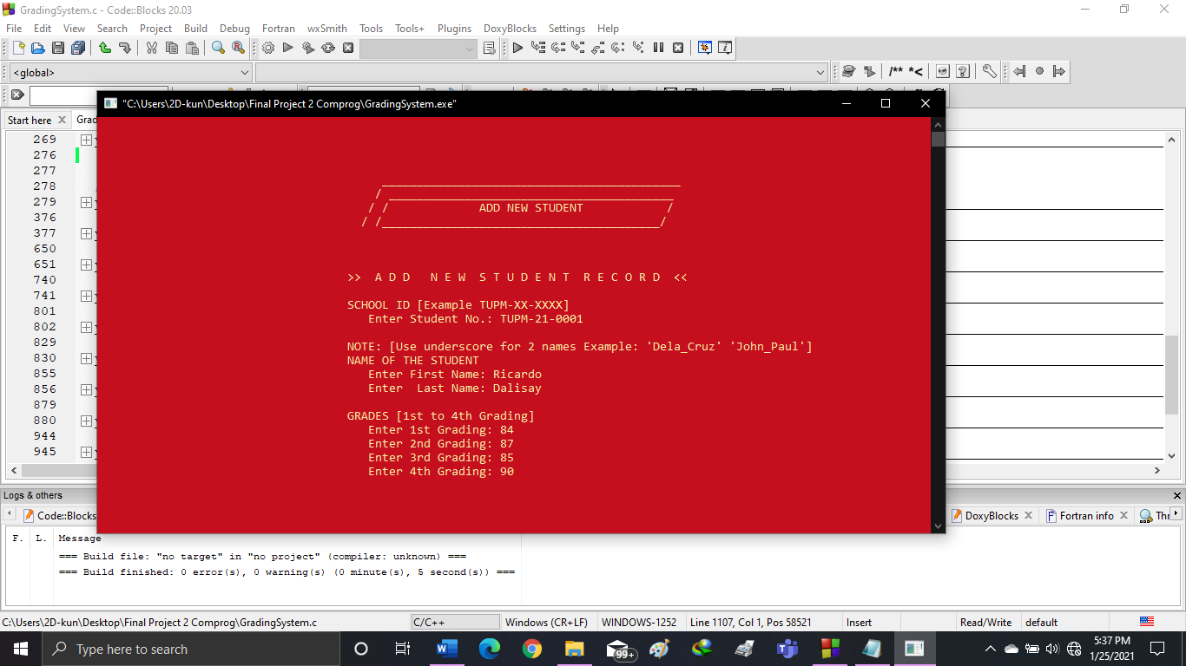

[1] Add New Student Record

This screen shows to input a new student record and it will save it to the database.

Enter a Student No:

Enter First Name and Last Name.  
NOTE: [if a student has 2 names, use underscore (_)]

And Enter the four Grades of the student.

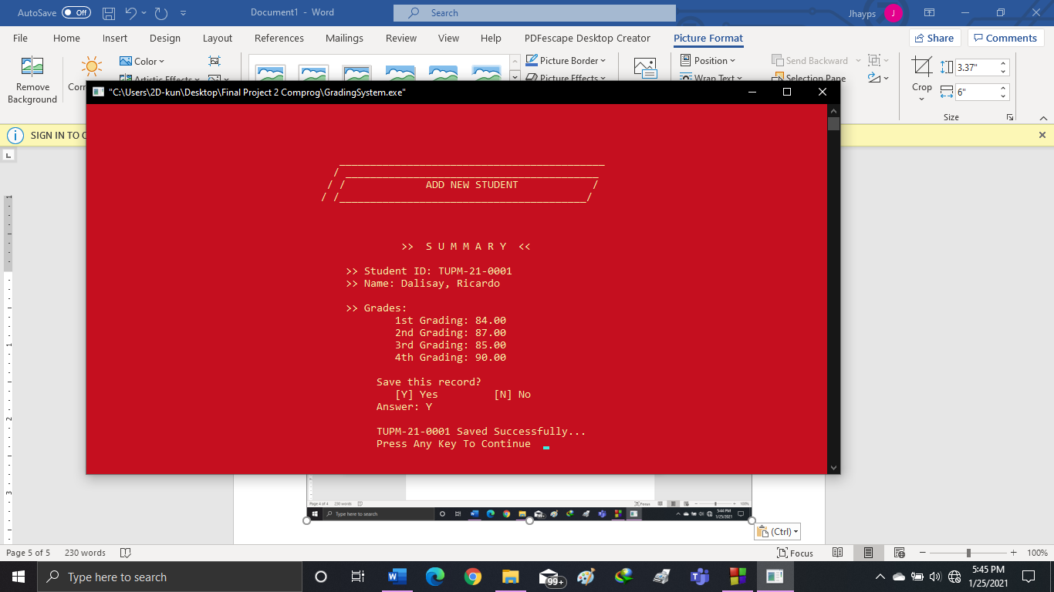

SUMMARY:

This will show the summary of the data that you entered.

Press [Y] to save this record to the database

Press [N] if otherwise.

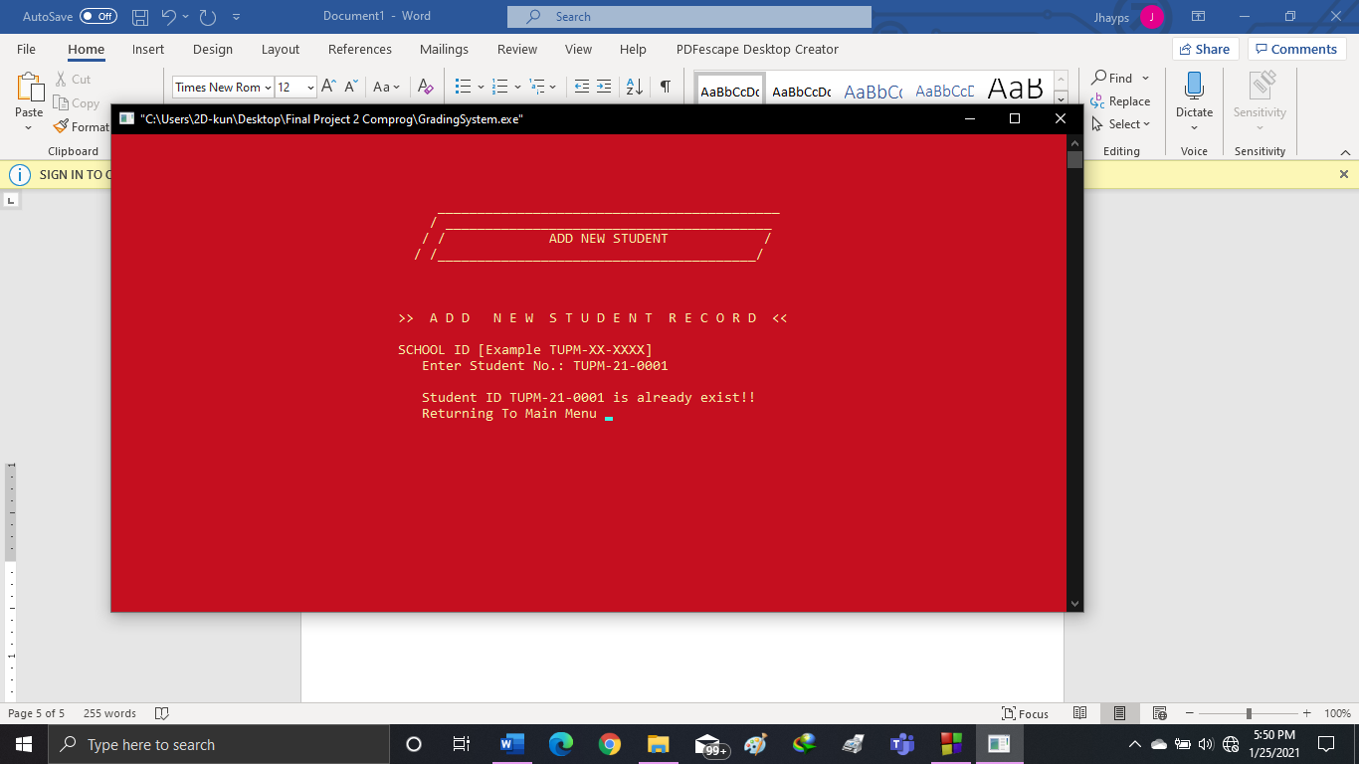

If you entered a student that already exist, it will leave a message and Press any Key to return to the Main Menu.

1. 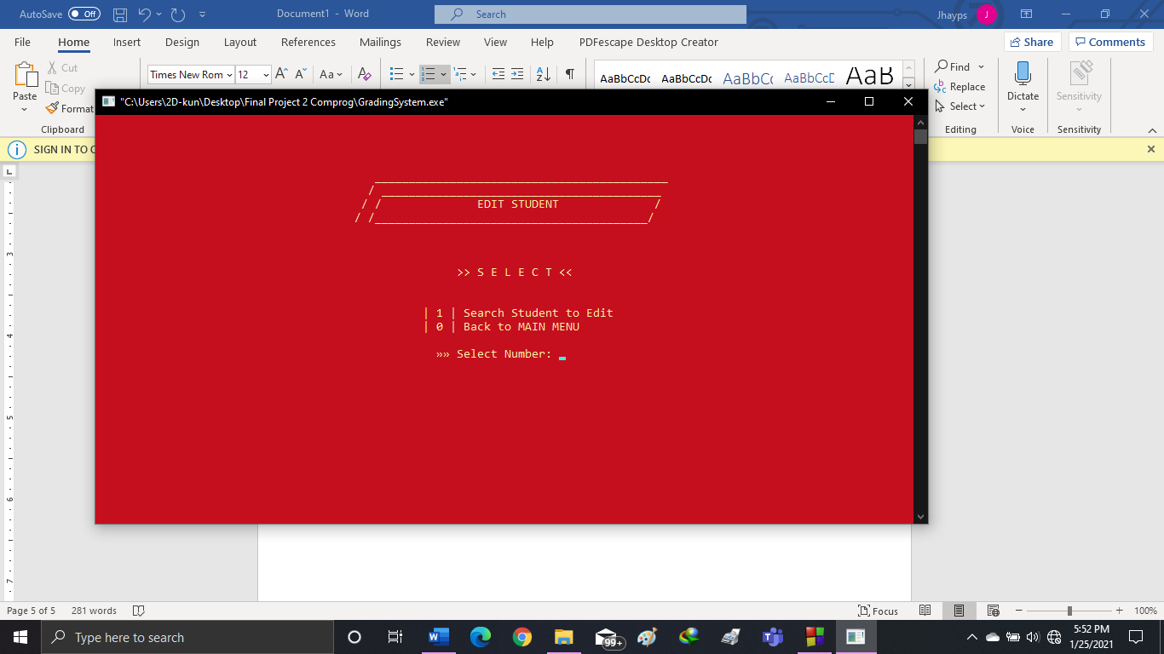EDIT STUDENT

If you Select the “Edit Student” in the MAIN MENU, it will show to this screen.

Press [1] to Select “Search Student to Edit” or Press [0] if you want to go back to MAIN MENU

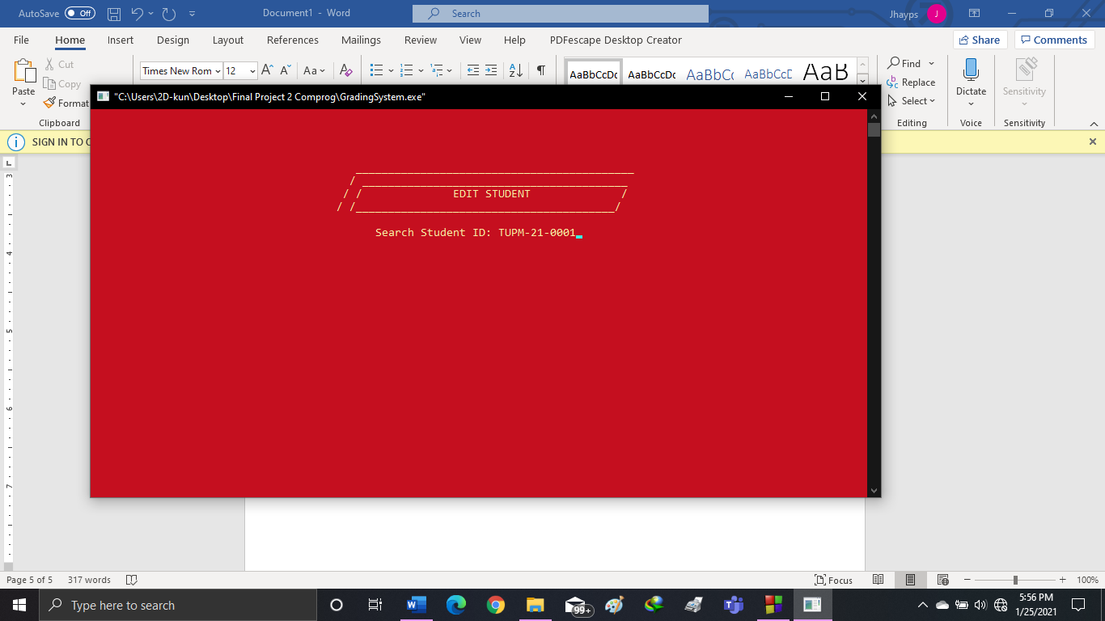This screen shows to search a Student ID to edit.

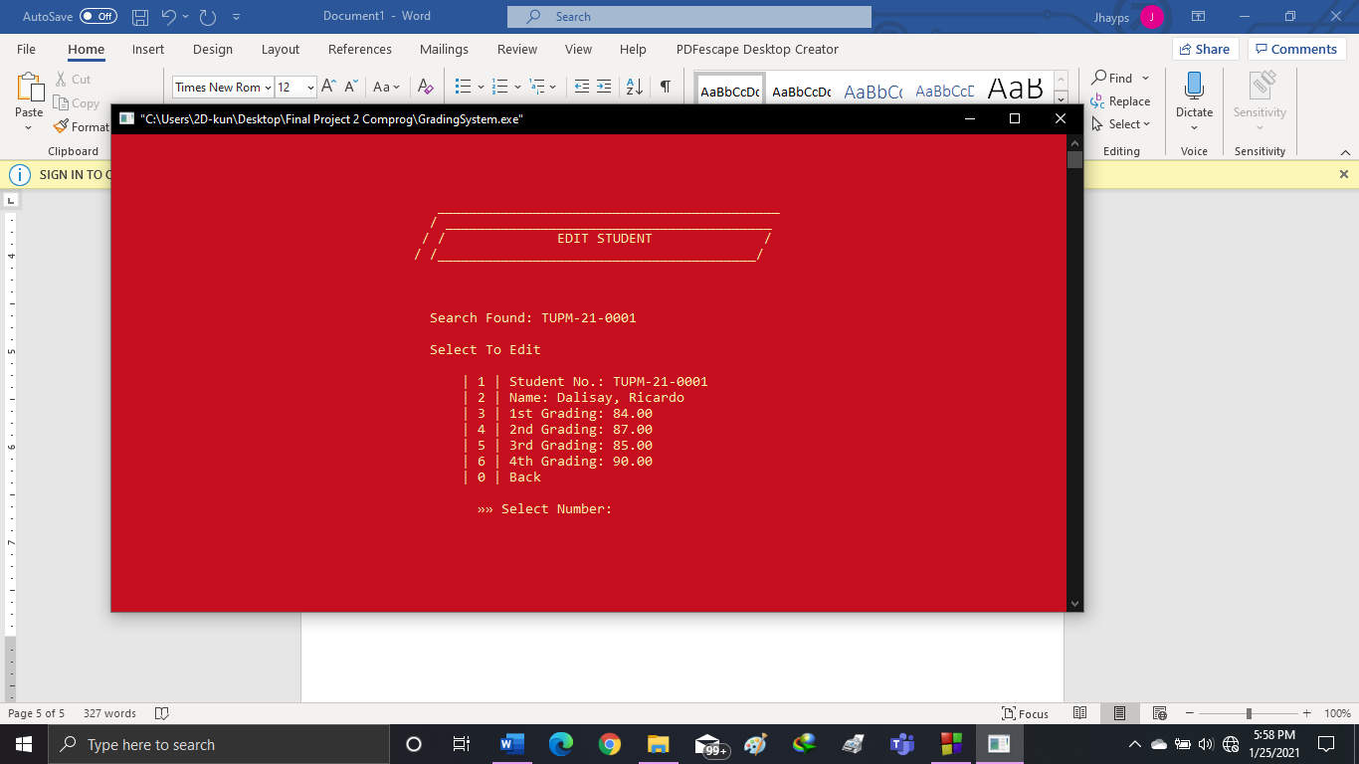

This is the screen if the searched ID is found.

Select a number you want to edit.

1. Student No.
2. Name
3. 1st Grading
4. 2nd Grading
5. 3rd Grading
6. 4th Grading
7. Back (Go back to the Edit Student Screen)

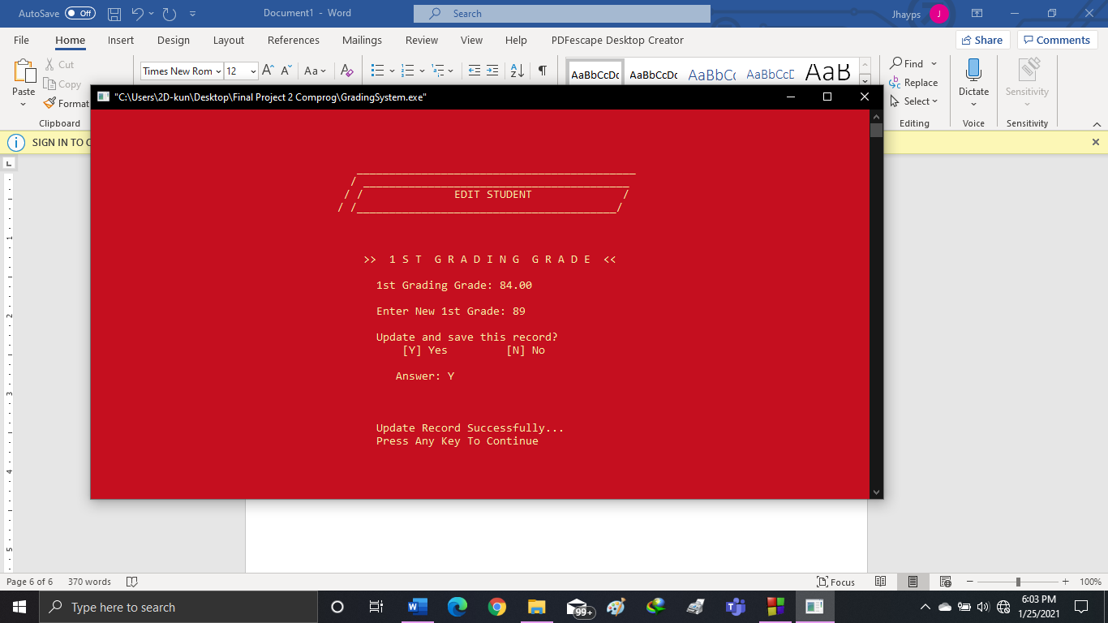

Editing Screen:

This will show if you select you want to edit and enter you want to change

Press [Y] to save.

Press [N] to not save the new record.

1. 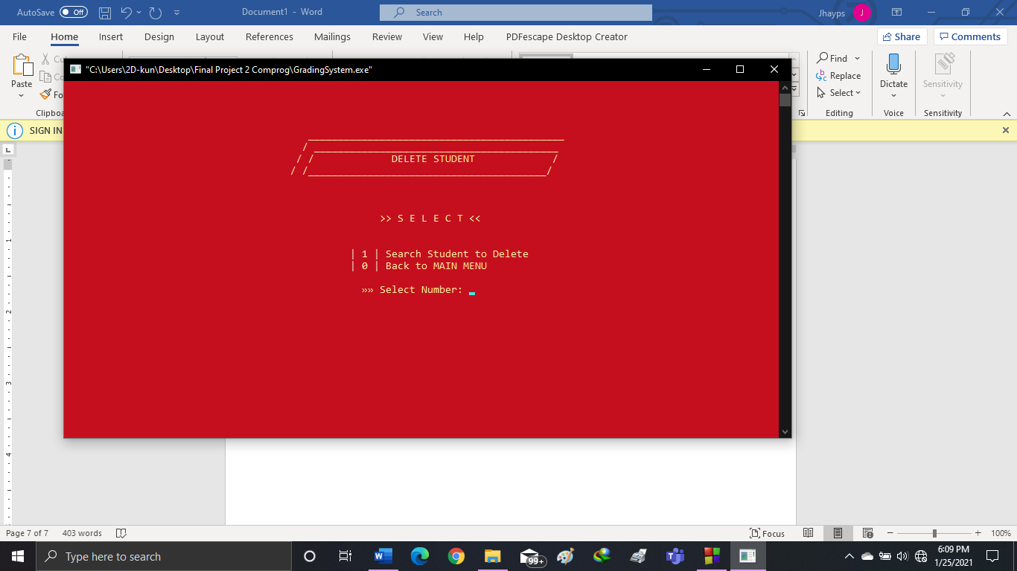DELETE STUDENT

If you Select the “Delete Student” in the MAIN MENU, it will show to this screen.

Press [1] to Select “Search Student to Delete” or Press [0] if you want to go back to MAIN MENU

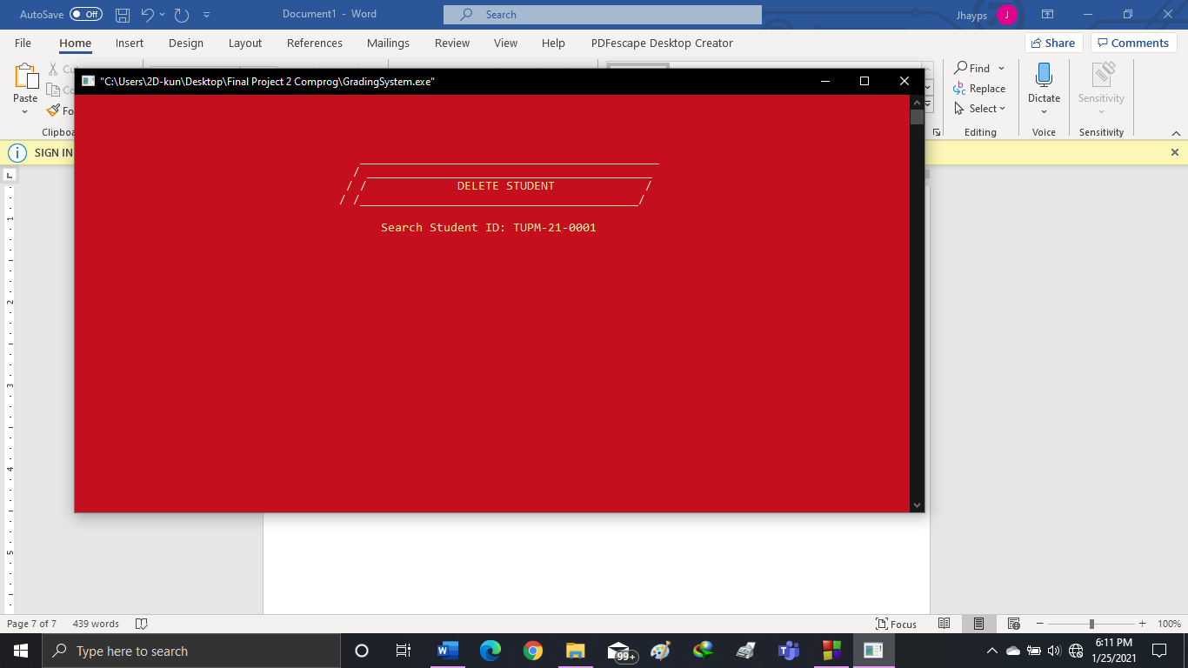

This screen shows to search a Student ID to Delete.

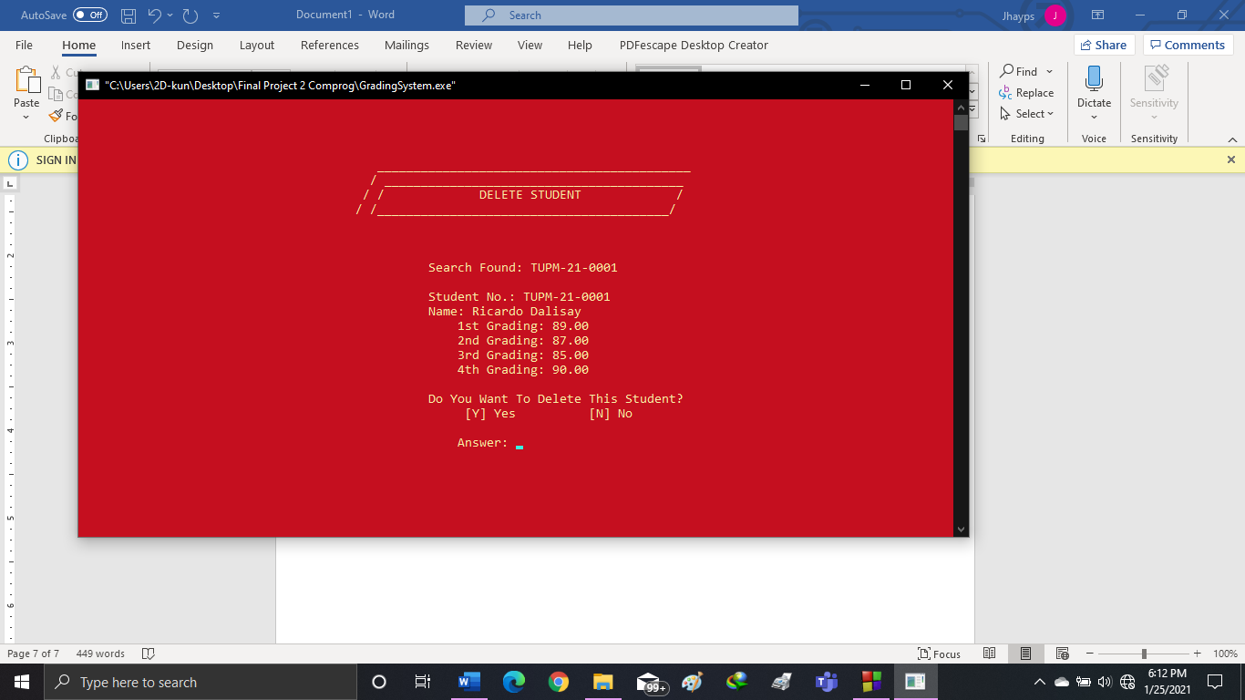

This is the screen if the searched ID is found.

Press [Y] to Delete.

This record will be saved at the Drop Students.

Press [N] if not.

1. 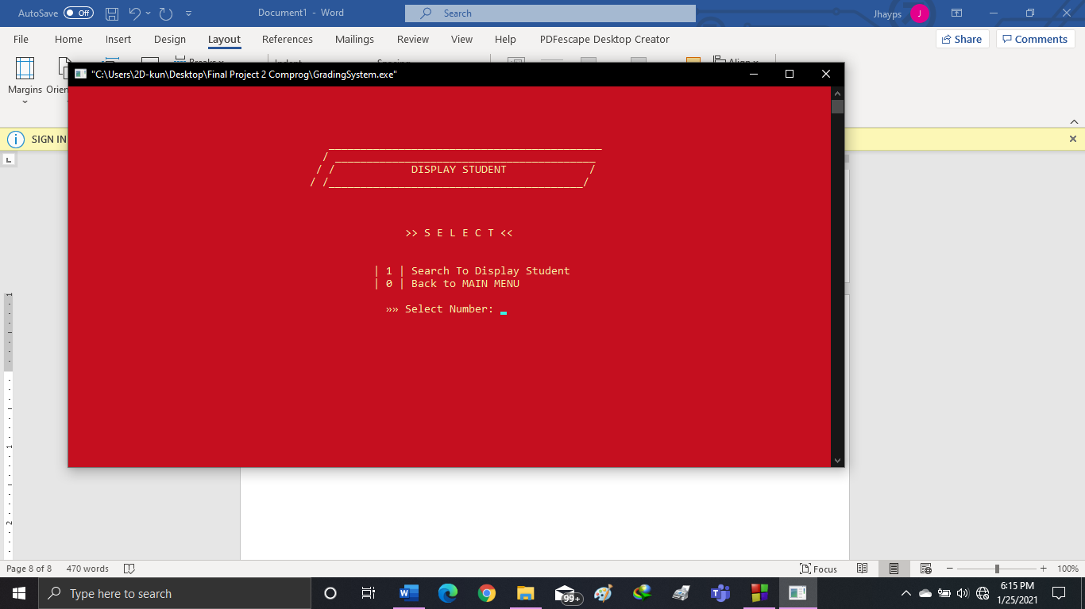DISPLAY STUDENT

If you Select the “Display Student” in the MAIN MENU, it will show to this screen.

Press [1] to Select “Search Student to Display” or Press [0] if you want to go back to MAIN MENU

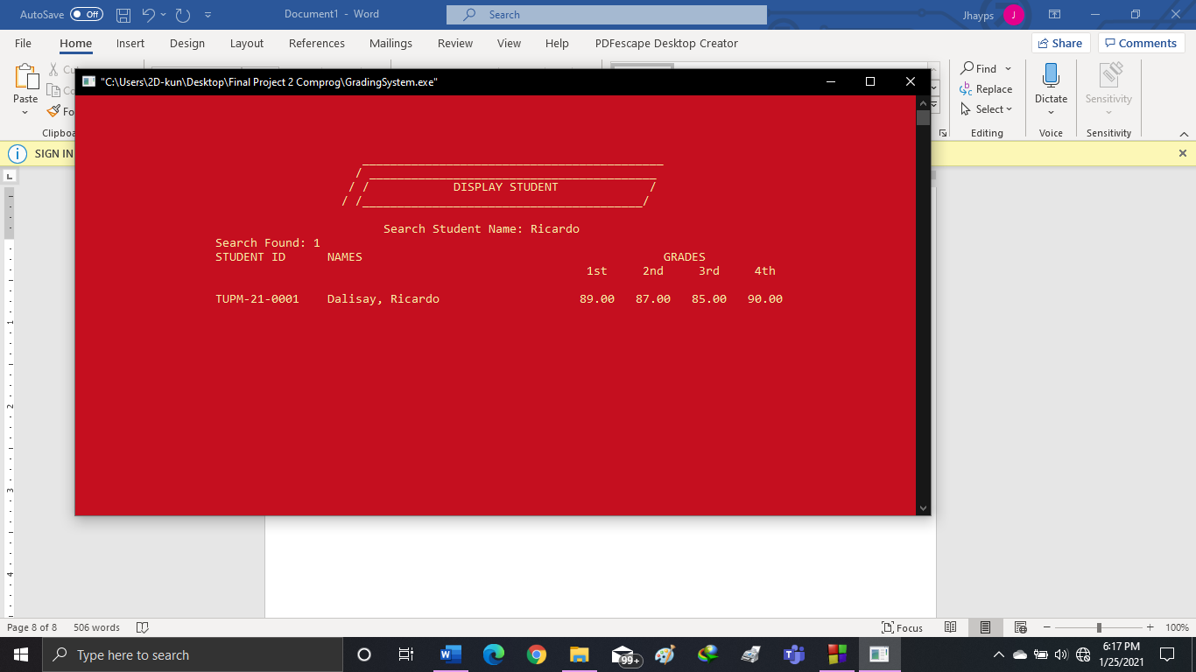 Search and Enter any Student Name and it will show the results.

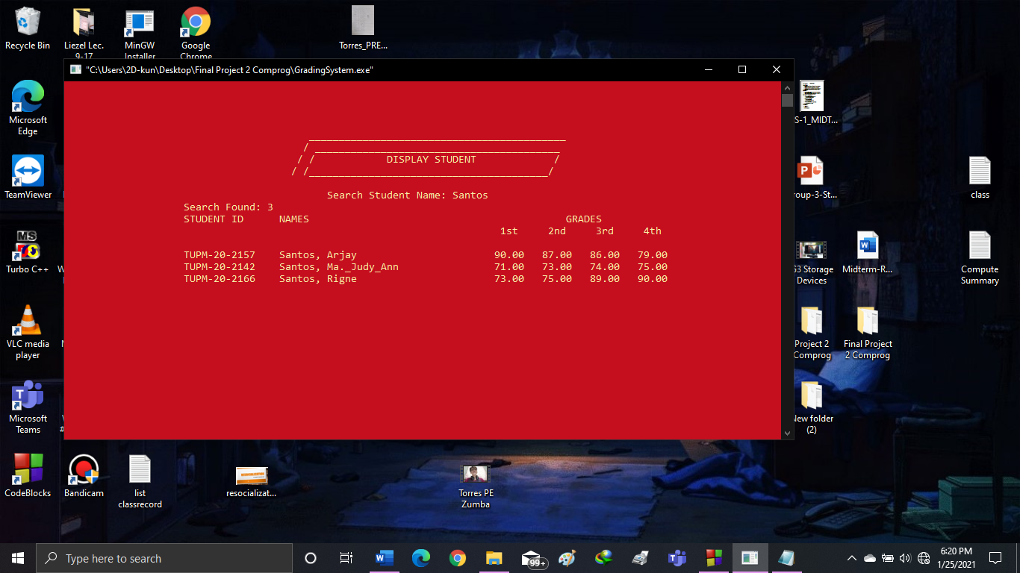

It will also show the result if has a multiple student with a same name.

1. 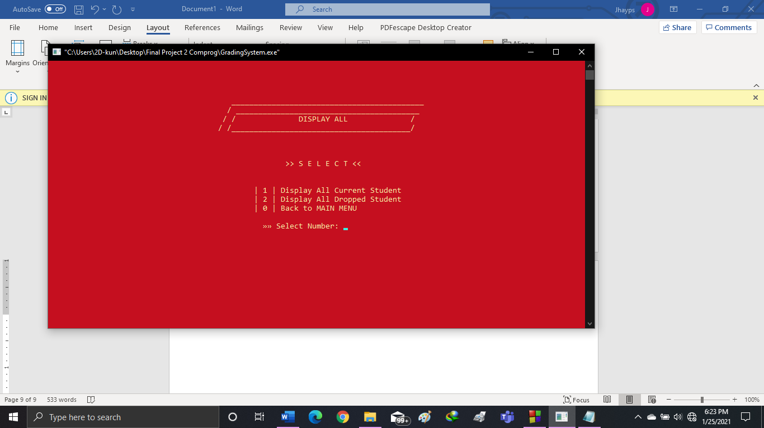DISPLAY ALL

If you Select the “Display All” in the MAIN MENU, it will show to this screen.

Press [1] to Select “Display All Current Student”

Press [2] to Select “Display All Dropped Student”

Press [0] if you want to go back to MAIN MENU

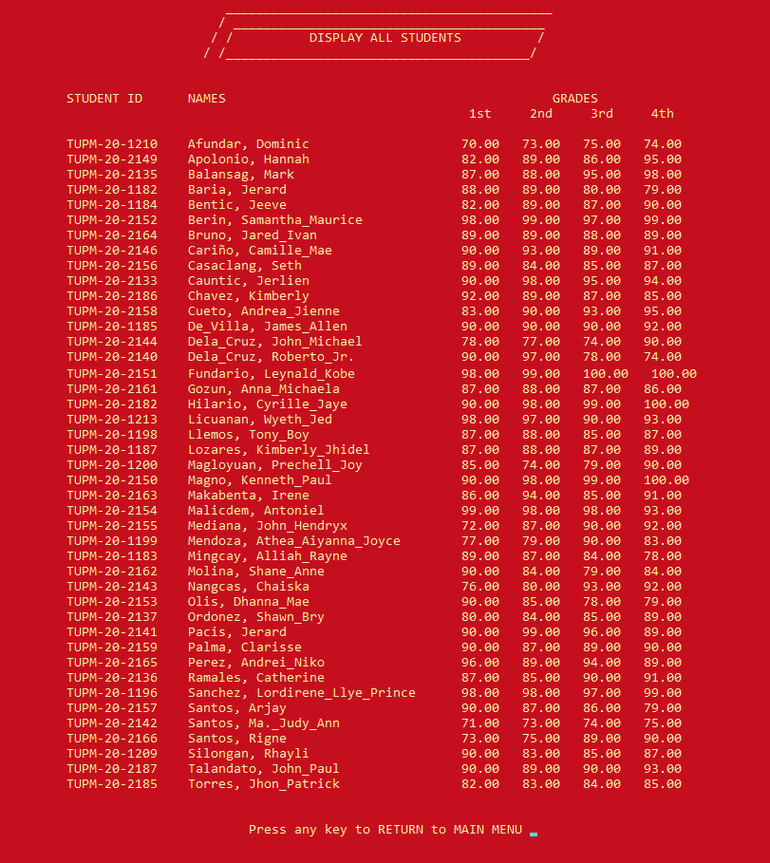

[1] Display All Current Student  
This Screen Displays All Current Students.

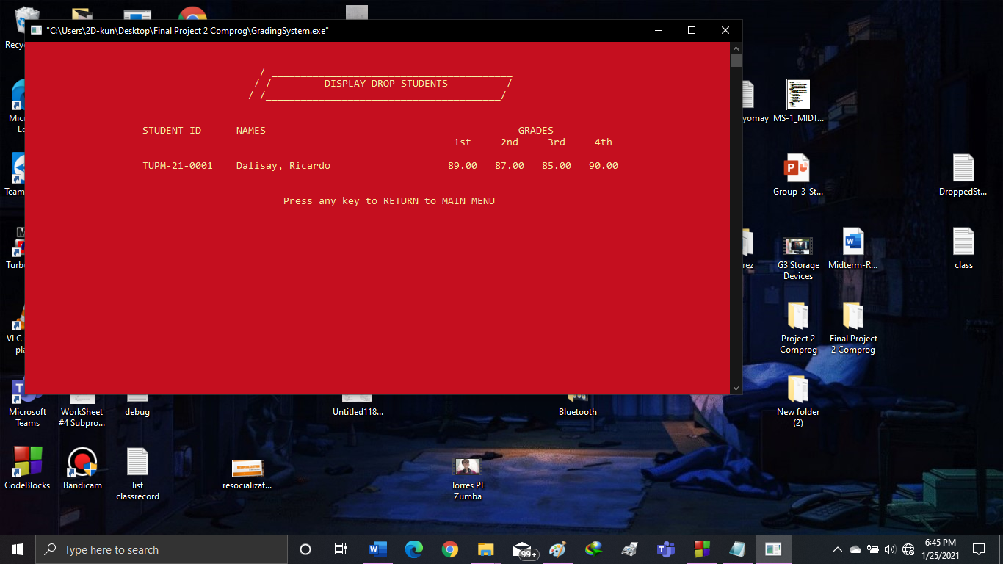

[2] Display All Dropped Student  
This Screen Displays All Deleted or Dropped Students

1. COMPUTE GRADE

This program shows the computation of average of the students. In this page will also determine the letter grade of each student.

A = 90 and Above  
 B = 81 – 89  
 C = 75 – 80   
 F = Below 75

It also shows the Total number of students, passed, rate of passed, failed and the rate failed.

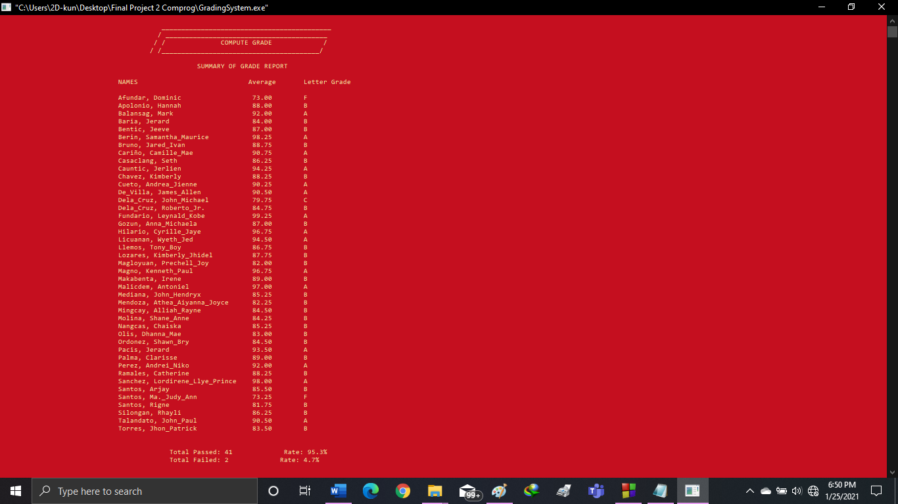

1. GENERATE GRADE SUMMARY

This shows the summary of the generated grade of all the students. It shows the Student ID/Number, Name, GWA, and Remarks

It also shows the Total number of students, passed, and failed.

It always requires to “[6] Compute Grade” first to show the generate grade summary.

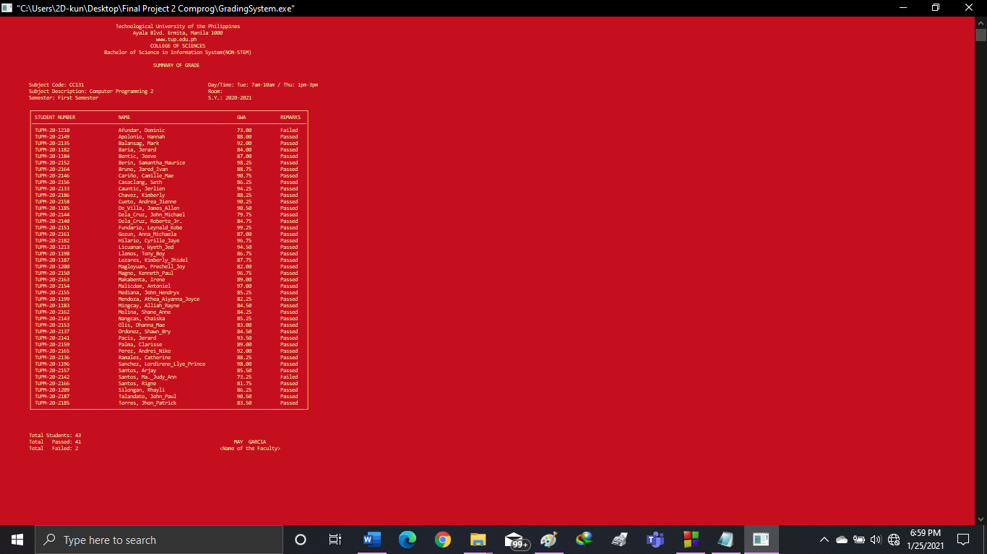

1. 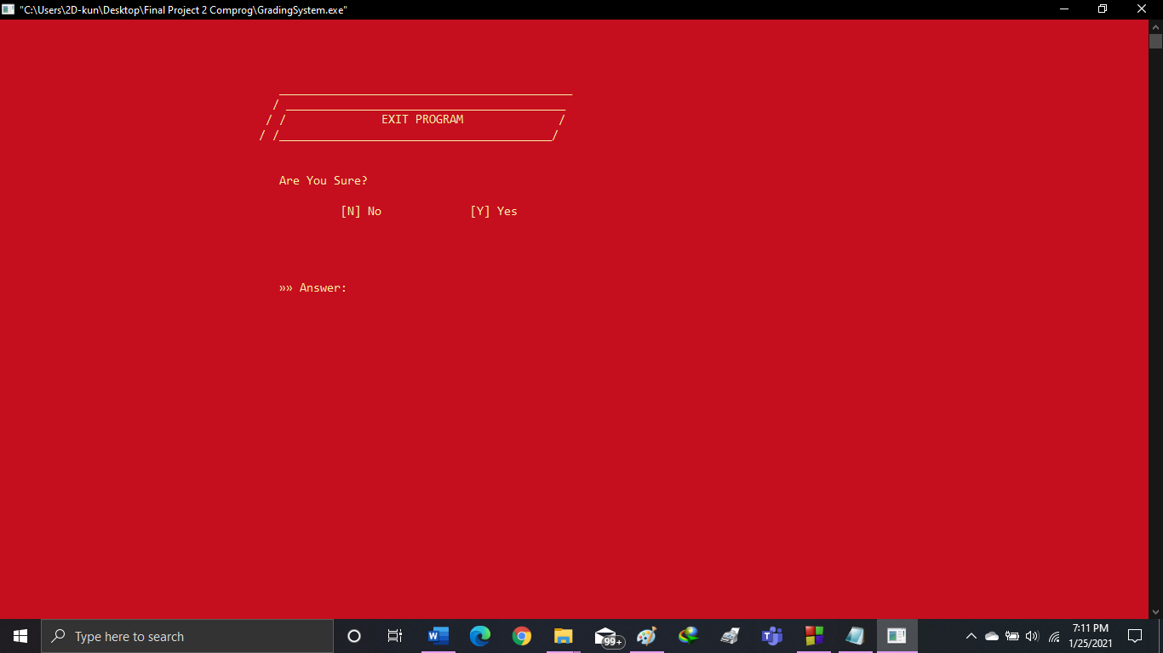EXIT

If you Select the “Exit” in the MAIN MENU, it will show to this screen.

Press [Y] to Exit Program.

Press [N] to go back to MAIN MENU

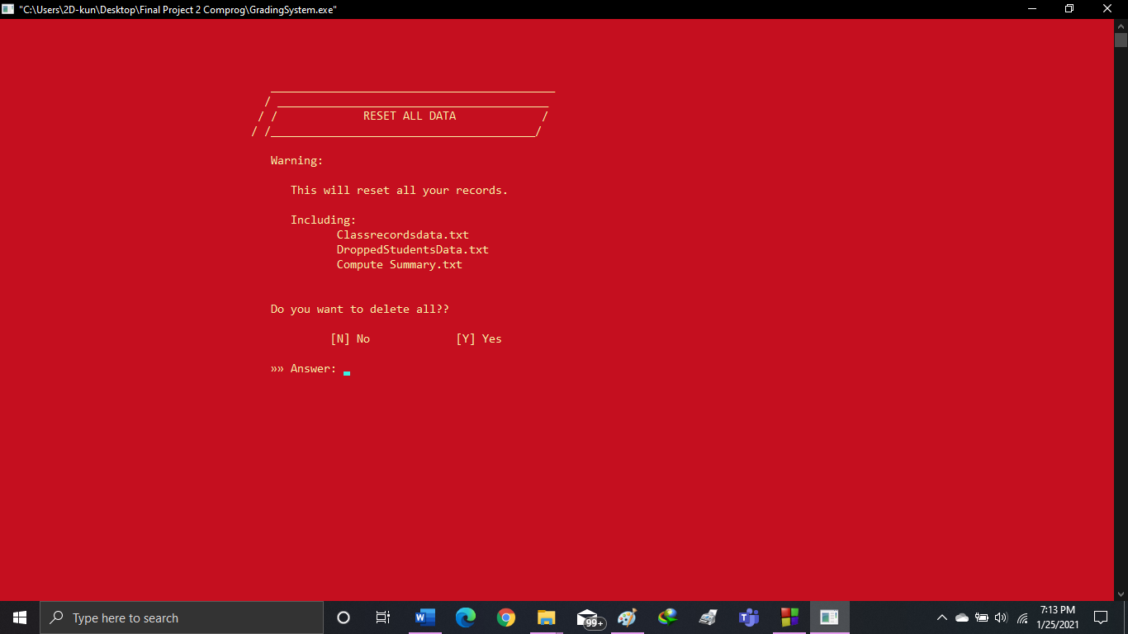R. Reset All

In the MAIN MENU, there is a hidden function called Reset All.

Press capital [R] to go to “Reset All Data” Screen.

It will show you a warning.

Press [N] if you don’t want to reset.

Press [Y] if you want Delete All.